LAB 8: IDA Pro
Course Name: Malware Analysis and Reverse Engineering (IAM302)
Student Name: Nguyễn Trần Vinh – SE160258
Instructor Name: Mai Hoàng Đỉnh
Lab Due Date: 15/2/2023

Purpose
- You will practice using IDA Pro.
- You should already have the lab files
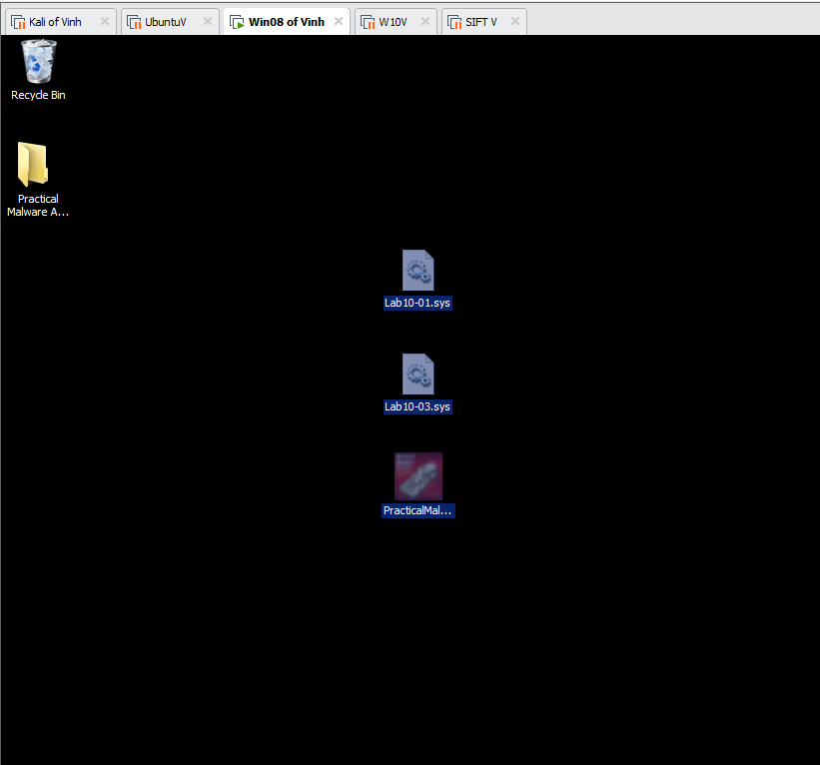

What you need:
- A Windows machine, real or virtual, such as the Windows 2008 Server VM we've been using
- The textbook: "Practical Malware Analysis"

Downloading and Installing IDA Pro
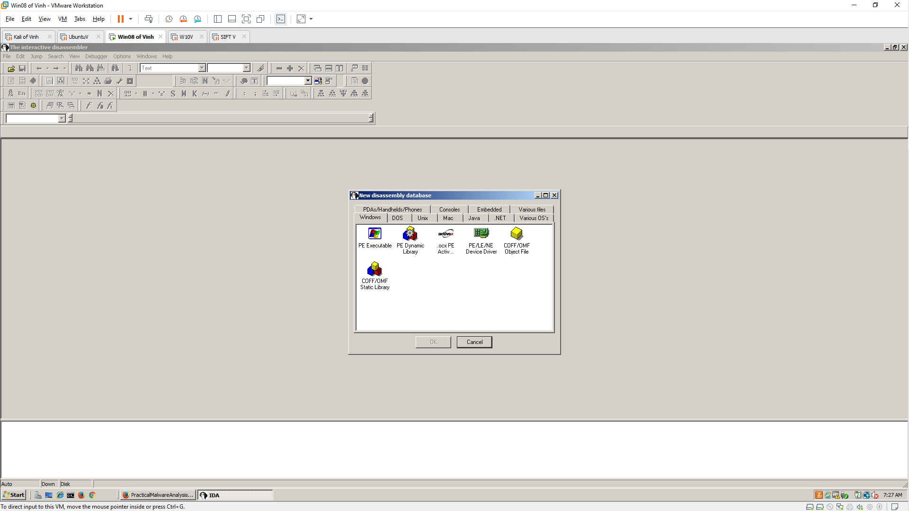

Follow the Textbook
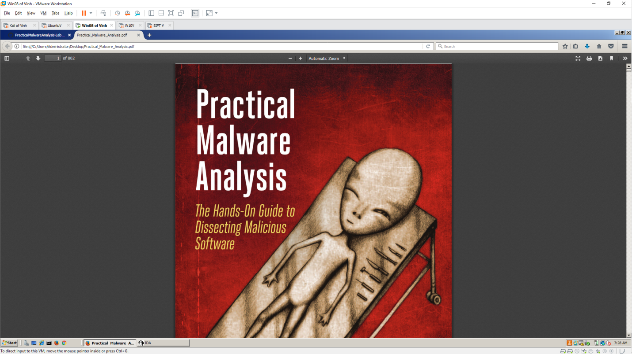

Opening Lab05-01.dll in IDA Pro
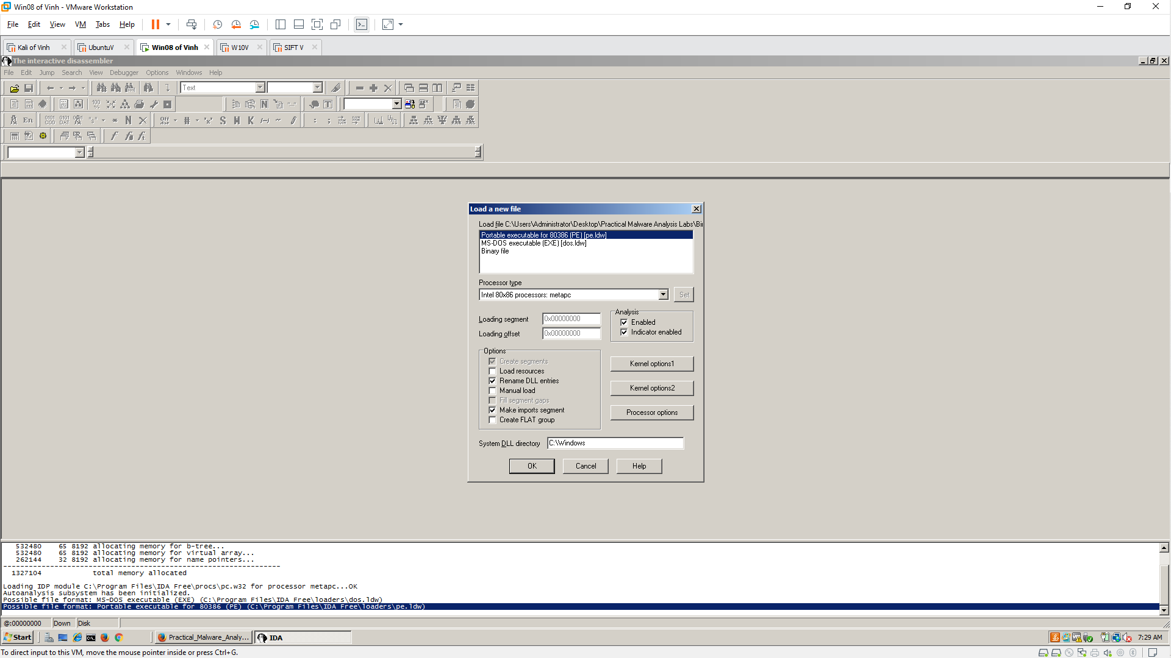

Q1: Finding the Address of DLL Main
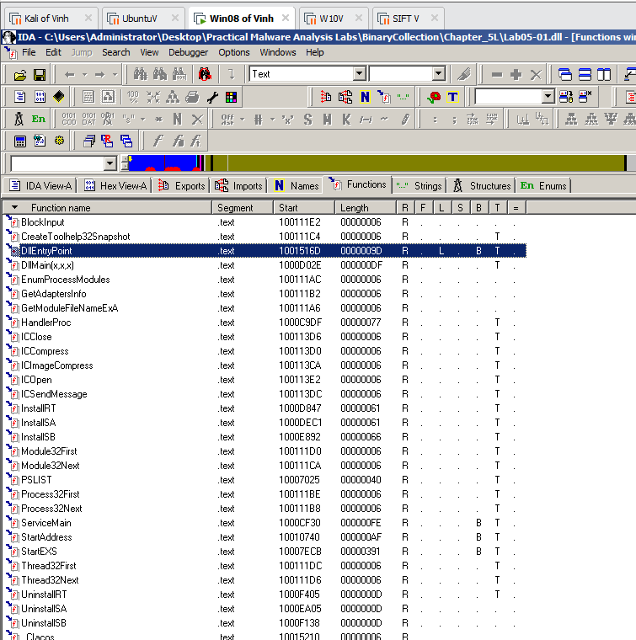

Q2: Find the import for gethostbyname
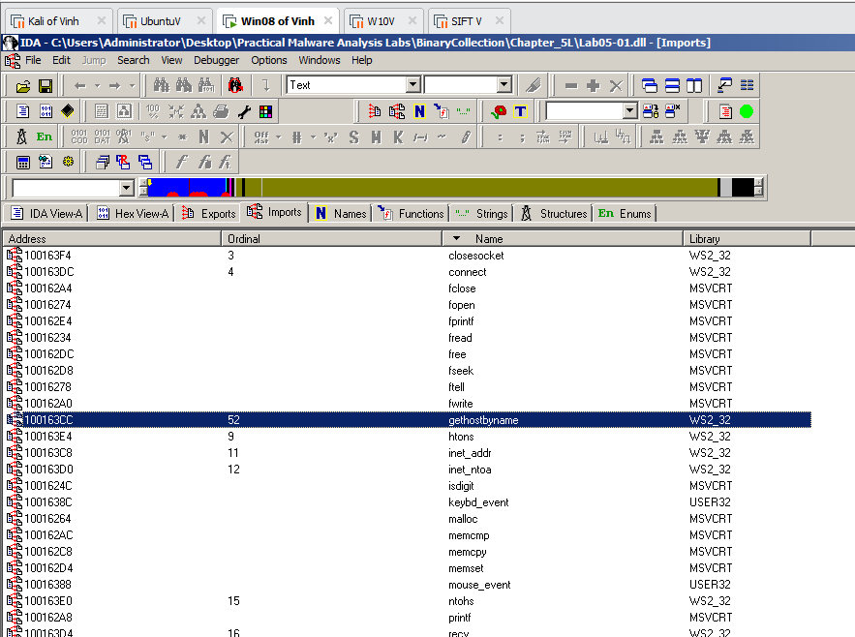

Q3: How many functions call gethostbyname?
- 9
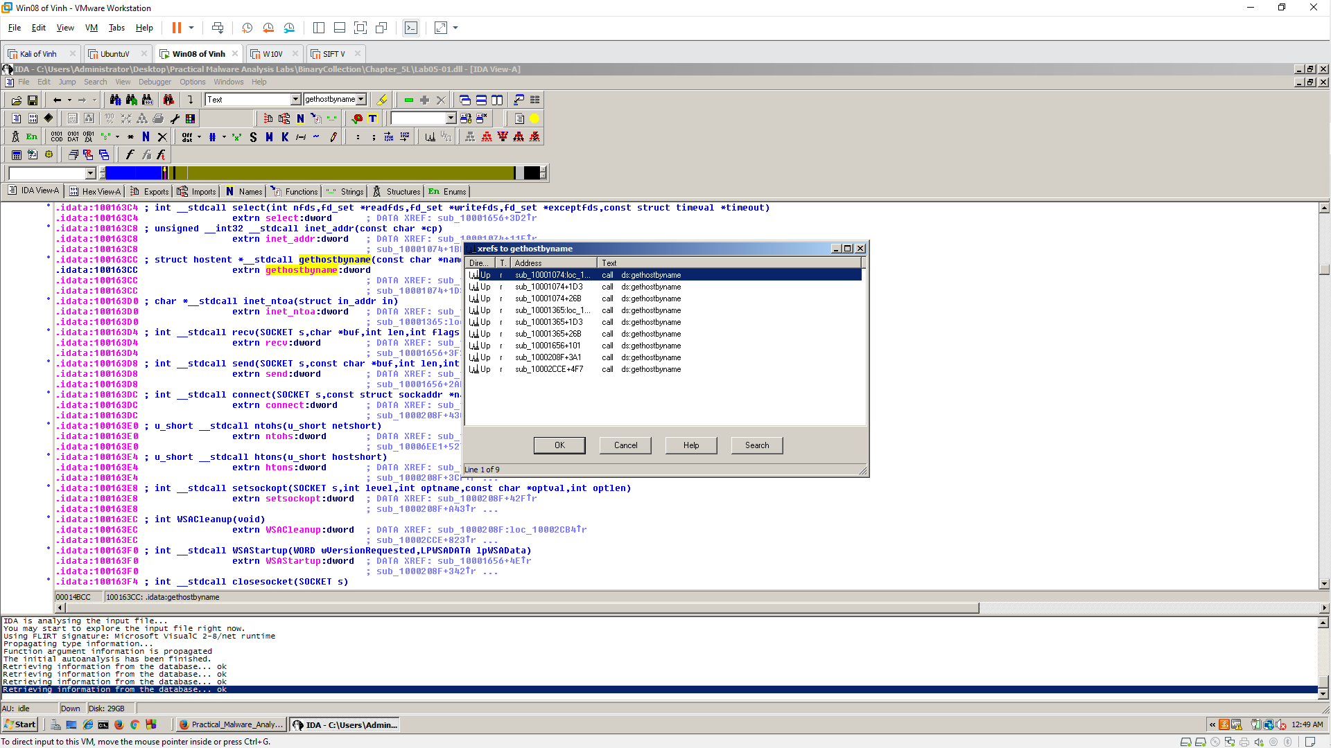

Q4. Focusing on the call to gethostbyname located at 0x10001757, can you figure out which DNS request will be made?
- pics.praticalmalwareanalysis.com
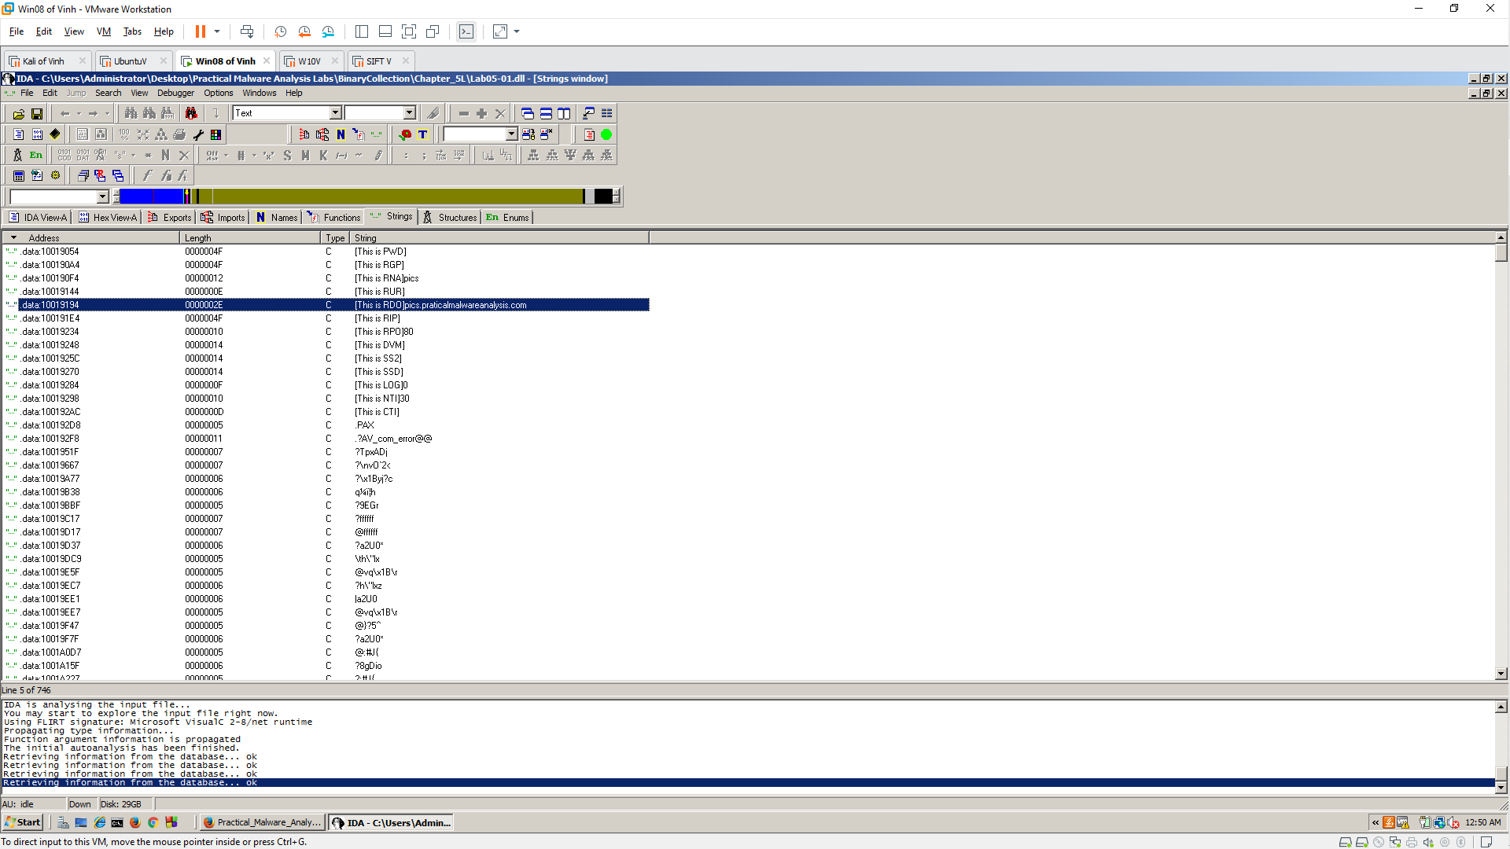

Q5: Count Local Variables for the Subroutine at 0x10001656
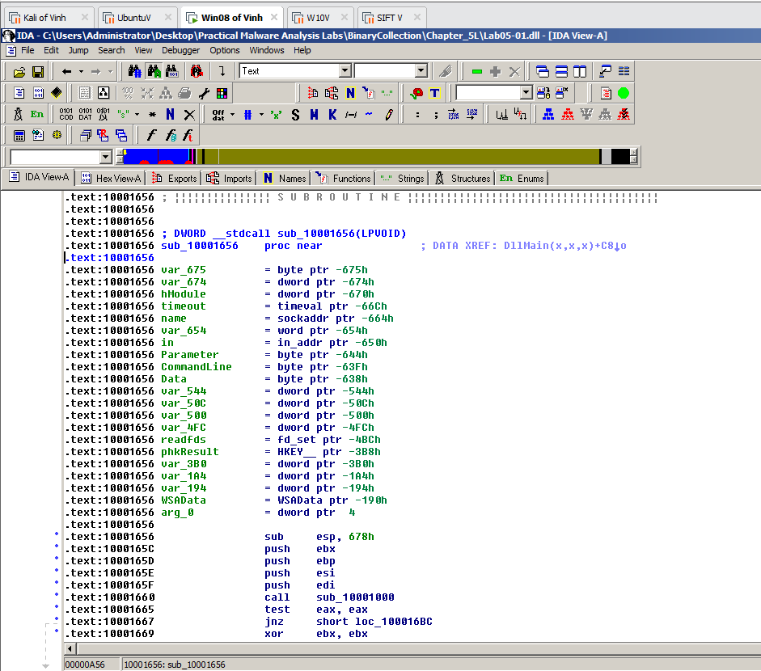

Q6: How many parameters has IDA Pro recognized for the subroutine at 0x10001656?
- 1
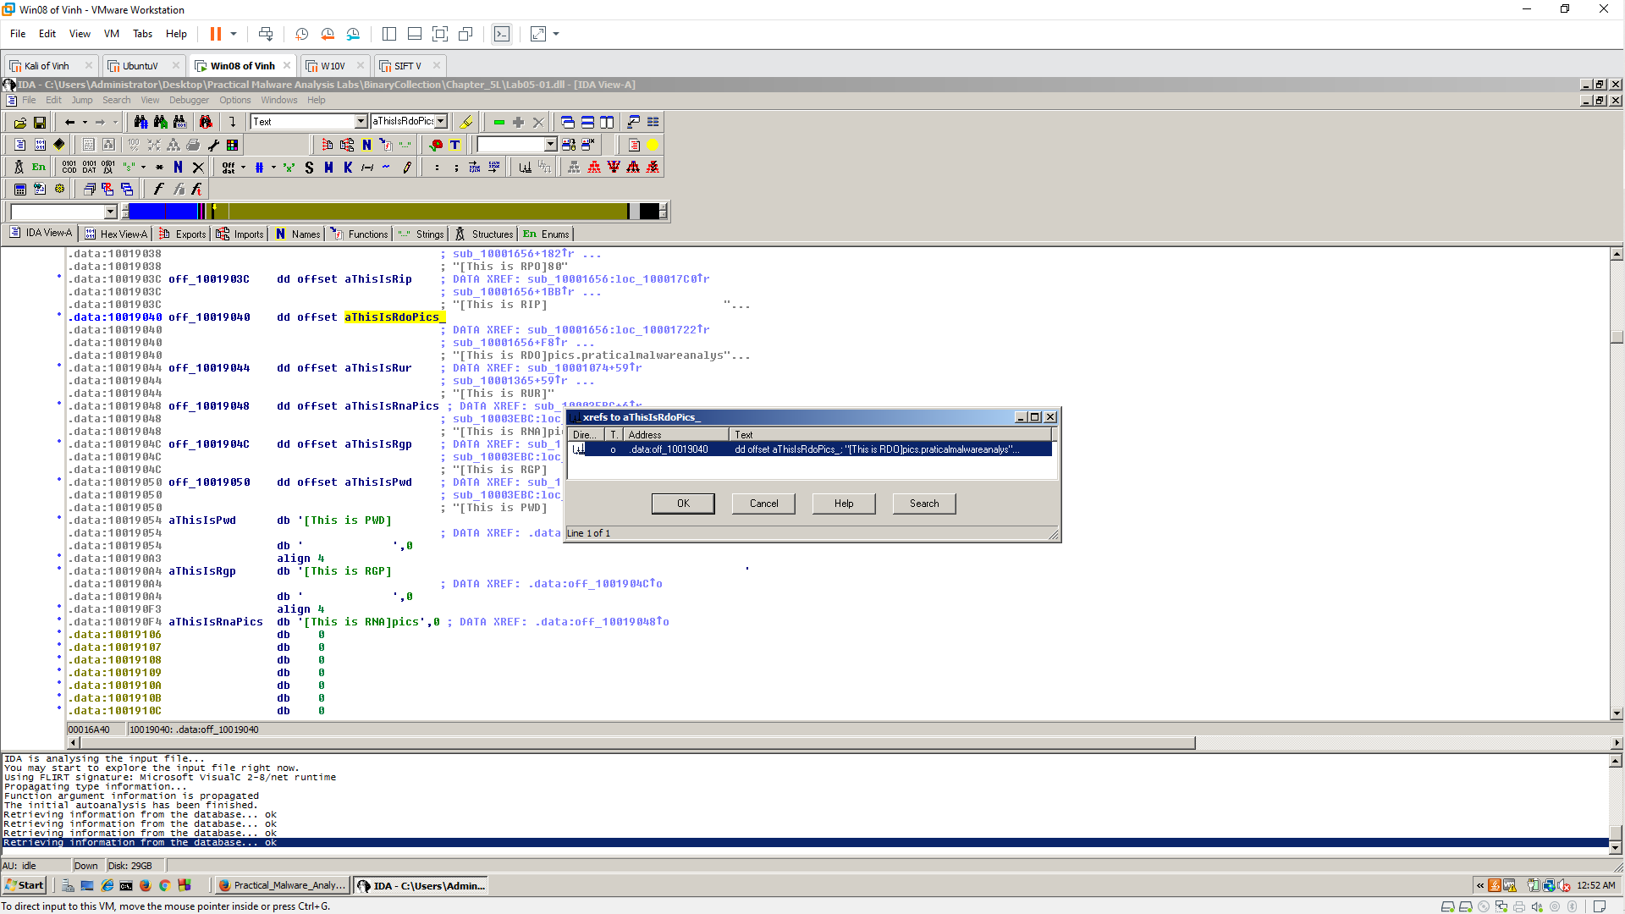

Q7: Use the Strings window to locate the string \cmd.exe /c in the disassembly. Where is it located?
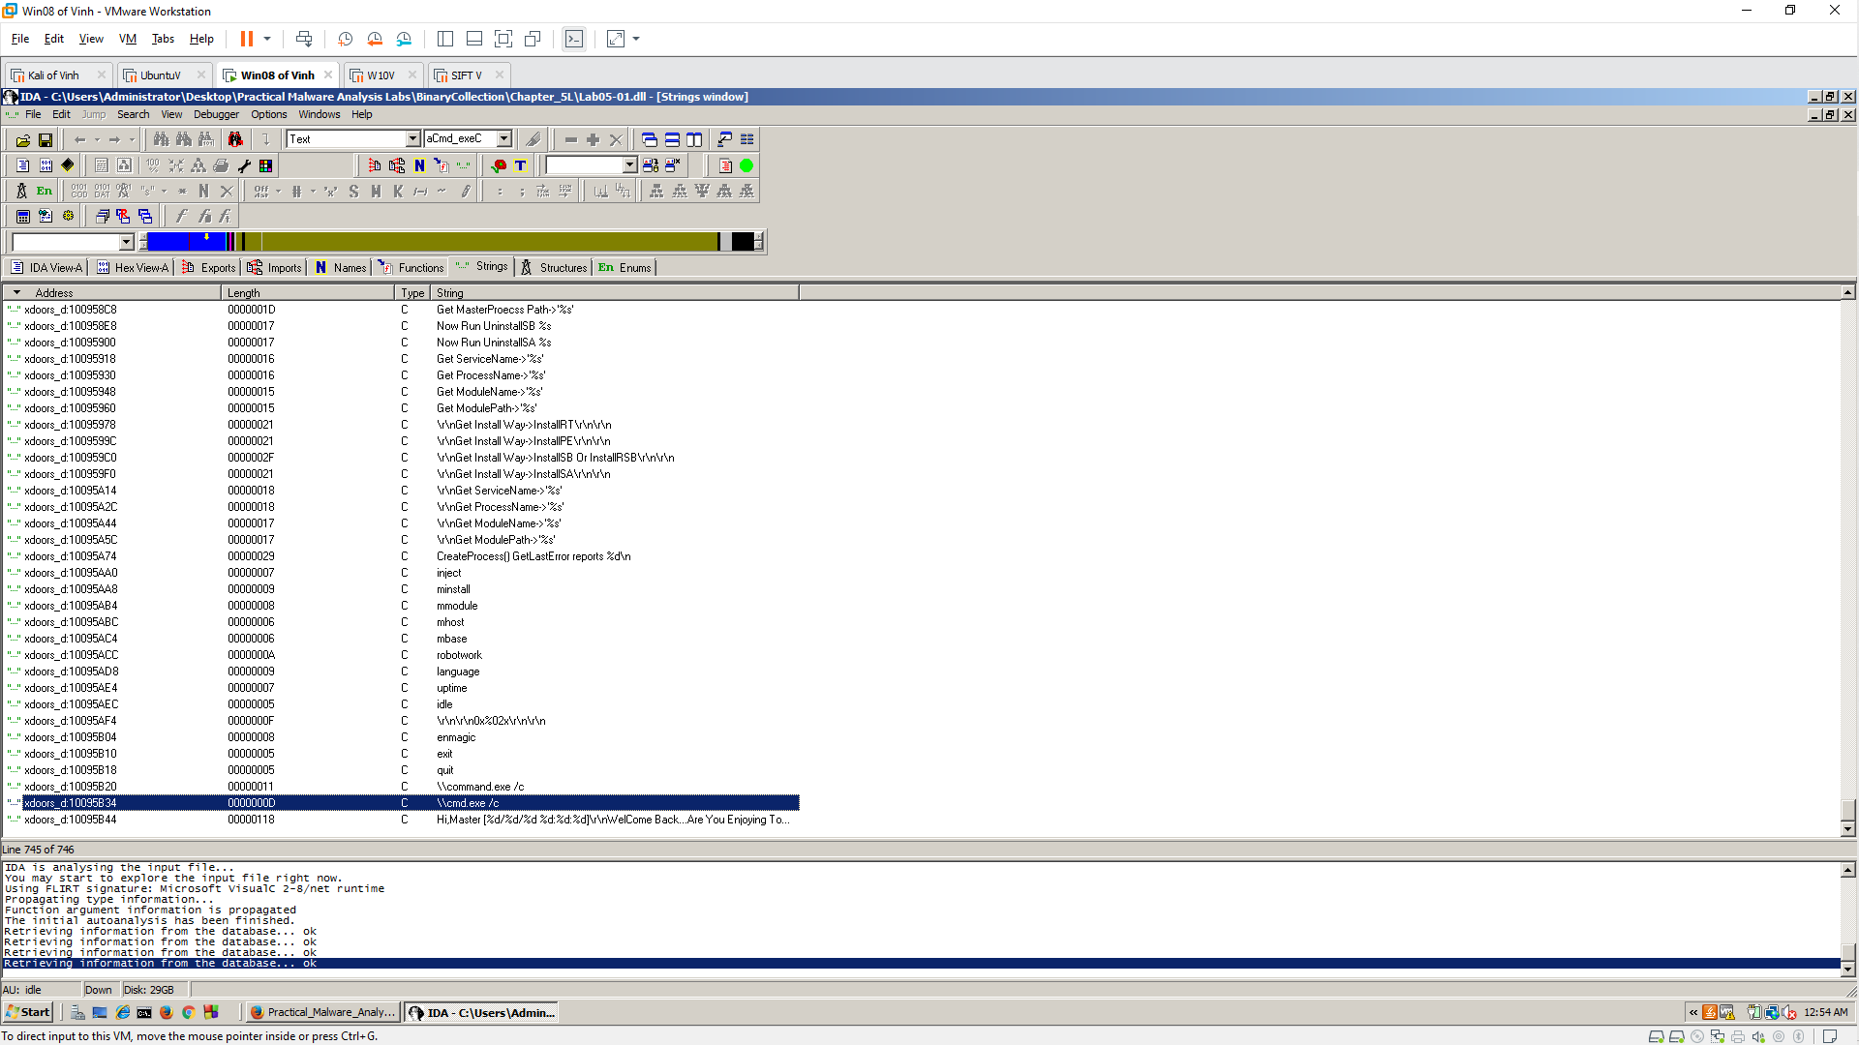

Q8: Finding the Purpose of the Code that References \cmd.exe /c
